
Daniel Natal, President Norma Borja Kroll, Beautification Coordinator
Robert McAlister, Neighborhood Watch Coordinator Denise Serbay, Newsletter Editor
Aurea Natal, Treasurer Kate Grande, Secretary
Susana Sotillo, Secretary Rich Rockwell, Web Master
http://www.halcyonpark.org/
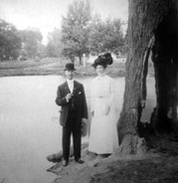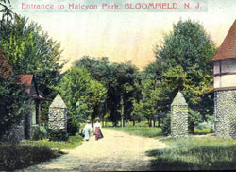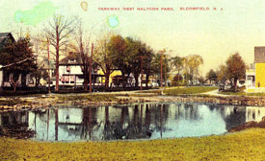
Fall 2009 (September, October, November) Volume 6 No. 8
President’s Message:

I hope everyone enjoyed the summer months despite the long rainy season we all experienced.

As tree leaves begin to fall and the weather changes, I would like to welcome all the young families that have moved into the park. We welcome them and hope that they become actively involved in our HPNA activities.

We are planning a Halloween parade and activities for children. We welcome everyone’s assistance with this event. If you have young children and would like to plan safe and fun activities for our neighborhood children, please contact me at your earliest convenience at 973-259-1337.

We would also like to encourage everyone to make an effort to show up at the regularly scheduled Town Council meetings every Monday at 7:30 p.m. to voice your concerns with respect to parking, zoning code violations, potholes, and illegal rooming houses in the park, and other factors that directly affect the quality of life and safety in Halcyon Park. If you need to reach our Third Ward Councilman, Robert Ruane, please call him at 201-513-1988. Feel free to email him at rmrsr2345@yahoo.com, speeding in the park by irresponsible drivers, zoning code violations, and neighborhood safety.

Daniel Natal, President
Halcyon Park Neighborhood Association

IMPORTANT PHONE NUMBERS OF BLOOMFIELD

Mayor’s Office – Pam Walsh Phone: 973-680-4080

Paul Lasek - Room 203-Municipal Building Phone: 973-680-4009
E-Mail: engineering@bloomfieldtwpnj.com (please report dumping of trash in storm drains)

Police Department (non-emergencies) 973-680-4141

Health Department (H1N1 Flu Information) 973-680-4124 or 4024

News from the Beautification Coordinator – Normal Borja Kroll http://recreation.bloomfieldtwpnj.com/bloomfield_recreation_department.htm

I am trusting you are enjoying this beautiful fall weather. I would like to thank all the residents who are helping us maintain the beauty and charm of Halcyon Park. It was so beautiful to see this past summer how many residents added flowers to our flower beds at the park. We thank you and appreciate you!

Please remember that you must use recyclable paper bags for your leaves. IT'S THE LAW! The town will pick up these bags every week on your recycle day. Please DO NOT use plastic bags to dispose of your leaves, the town will not pick up these plastic bags with your leaves.

I would also like to remind residents and visitors to the park that you must keep your dogs on leash and also PLEASE PICK UP AFTER YOUR DOG. IT'S THE LAW!

Have a Colorful and FUN FALL

Norma Borja Kroll

SAY HEY! By Denise Serbay

Hi Neighbors,
As summer's warmth fades to Autumn's beauty (and summer baseball yields to playoff baseball -go Yankees☺ -, football, basketball and hockey) it's good to reflect on the good things that have happened here in Halcyon Park over the past few months. We recently held a Neighborhood Meeting where we invited our Third Ward Councilman Robert Ruane, Councilwoman Patricia Spychala, and our new Police Chief Mark Leonard (who was kind enough to bring many of his staff from different departments). Community Policing Officers Kevin O'Connell and Jose Munoz gave an excellent presentation on safety tips. Our Neighborhood Watch president Robert McAlister gave a presentation as well and collected names, addresses and numbers for a neighborhood chain. That list was distributed at another great neighborhood event, The National Night Out held in August. Neighbors again met and mingled in a relaxed atmosphere, and again, our elected officials showed their support for our neighborhood.
Coming up, we are planning a Halloween Party for our neighborhood children. We are also hoping to have a Holiday Party. The idea is to hold the party in a small, affordable venue, such as a restaurant, and have a Santa Claus who will distribute presents to the children (bought by the parents). We hope to have music, fun, all around good cheer, affordably! If anyone is interested in these events, please contact Dan Natal.

We again invite all of you to become involved in the Neighborhood Association. Doing so does not involve a lot of time. A sense of community helps keep a neighborhood connected and safe. Please join us in keeping Halcyon Park a safe, beautiful, welcoming enclave for our present and future residents.

LOOKING AFTER OUR PARK by Susana M. Sotillo

I would like to encourage everyone to become actively involved in the Halcyon Park Neighborhood Association. Remember that your property taxes are used to finance our public school system, the County Executive’s improvements to parks and roads, and the State’s priorities.

Here is what John Palomaki; the coordinator for a Greener Bloomfield is doing to set a good example for everyone:
All of us must do our part to encourage positive improvements in our town, try to set a good example, and “walk the talk”. I drive a Prius hybrid (over 47 mpg and ultra low emissions), and our home renovation is on target to be the first LEED for Homes Platinum certified home in NJ. We can’t all do things at that level, but everyone can do a number of low- to no-cost things to make the world a greener and healthier place, from using reusable grocery bags to changing to more efficient light bulbs to walking and cycling instead of using their cars when possible to adding an extra layer of insulation in their attic and turning down their thermostats.
The township has been making a number of strong steps toward sustainability, with green building guidelines for Redevelopment, the Sustainable Land Use Pledge, water conservation and anti-idling ordinances, purchasing hybrid police and fire vehicles, pursuing waste vegetable oil to biodiesel fuel production, encouraging recycling, composting, and grasscycling, cutting the fuel budgets to encourage reduced consumption. We still need to get to a more sustainable financial situation somehow, and make some more tough choices, in order to reverse some of the decline you’re seeing, but I think we’ll get there, with your help and that of many others. (john@greenerbloomfield.org)

If you are interested in being part of an SMS (Short Message System) text messaging network for crime prevention in Halcyon Park, please text me at 201-341-0319. I have collected a number of cell phone numbers and am awaiting the construction of a Web site in order to field test the effectiveness of this type of crime prevention initiative. Captain James Decker has started an SMS text messaging initiative with a Web service, but this is a one-way means of communication. The Police Department can send us text messages informing us about a variety of safety issues or crimes committed in our area, but we cannot send text messaging tips to the Police Department. I am working with a professor from NJIT on getting this type of two-way SMS text messaging network implemented. If you search for this type of crime prevention initiative (SMS text messaging – Google) you will see that it already exists in all large and medium-size cities of the U.S.

A group of us has asked Councilman Ruane (201-513-1988) and the Township Administrator, Louise Palagano, to do something about two properties at the two main entrances to our park: Watsessing Avenue --Berkely Ave. and Parkway West -- Franklin Street. As it must be obvious to most of you, one of the historical houses at the Watsessing entrance to Halcyon Park is in terrible disrepair and nothing is being done to address this situation. When prospective buyers come into our park, this is what they notice and it discourages most of them. Those entering the park from Franklin St. -- Parkway West are greeted by hideous corn stalks that remind one of the horror films, Children of the Corn. As some of you, I pay over $8000 in property taxes and expect to live in an attractive and safe enclave, but these two properties are ruining property values for all of us. The town must enforce zoning laws and aesthetic ordinances in place. If you want to join me in finding a legal way to deal with this particular issue, please call me at 201-341-0319.

A word from our Sponsor:
BARBARA P. HUGHES ePRO, GREEN
REALTOR®/SALES ASSOCIATE
2009 West Essex Bd of REALTORS, REALTOR of the YEAR
THE NICHOLAS TEAM
RE/MAX VILLAGE SQUARE REALTORS
516 Valley Road Upper Montclair, NJ 07043
Office: 973-509-2222
Email: barbarahughes@remax.net On the Web: www.theNicholasTeam.com
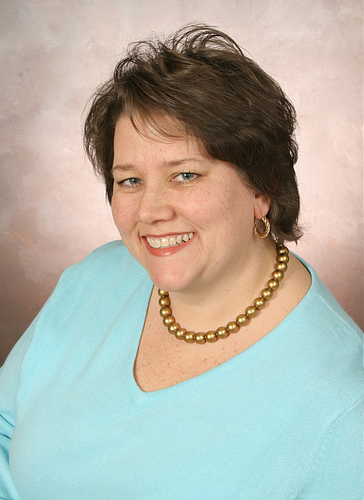

Let Uncle Sam Help Pay for Energy Efficiency Improvements
The $8,000 New Home Buyer Tax Credit (along with the Cash-for-Clunkers) may have dominated the headlines recently, but some energy efficiency Tax Credits offered by the federal government could be even more useful for the average homeowner. You may be eligible for a tax credit equal to 30 percent of the cost of materials (up to $1,500) for certain products purchased between January 1, 2009 and December 31st, 2010. As a GREEN® designated REALTOR®; I can help you answer many questions you might have about these and other tax credits & incentives. For more information check out my website: www.TheNicholasTeam.com to find out more, or give me a call today 973-509-2222
Below are the rating specifications for eligible energy efficiency products:
Product Category | Product Type | Tax Credit Specification
Insulation | Insulation | Meets 2009 IECC & Amendments
Windows & Doors | Windows, Doors, and Skylights | Before June 1, 2009:  Must meet ENERGY STAR criteria  After June 1, 2009:  U factor <= 0.30 SHGC <= 0.30
Windows & Doors | Storm Windows & Storm Doors | In combination with the exterior window over which it is installed:  - has a U-factor and SHGC of 0.30 or below  - Meets the IECC
Roofing | Metal Roofs,  Asphalt Roofs | All ENERGY STAR qualified metal and reflective asphalt shingles
HVAC | Central A/C | Split Systems: SEER >= 16, EER >=13  Package systems: SEER >= 14, EER >= 12
HVAC | Air Source Heat Pumps | Split Systems: HSPF >= 8.5, EER >= 12.5, SEER >= 15  Package systems: HSPF >= 8, EER >= 12, SEER >= 14
HVAC | Natural Gas or Propane Furnace | AFUE >= 95
HVAC | Oil Furnace | AFUE >= 90
HVAC | Gas, Propane, or Oil Hot Water Boiler | AFUE >= 90
HVAC | Advanced Main Air Circulating Fan | No more than 2% of furnace total energy use.
Water Heaters | Gas, Oil, Propane Water Heater | Energy Factor >= 0.82  or a thermal efficiency of at least 90%.
Water Heaters | Electric Heat Pump Water Heater | Same criteria as ENERGY STAR: Energy Factor >= 2.0
Biomass Stove | Biomass Stove | Stove which burns biomass fuel to heat a home or heat water.  Thermal efficiency rating of at least 75% as measured using a lower heating value.
Extended Opportunities: The following upgrades are eligible for a 30% of cost tax credit (without an upper limit) if placed into service before December 31st, 2016:
Geo-Thermal Heat Pump | Geo-Thermal Heat Pump | Same criteria as ENERGY STAR:  Closed Loop: EER >= 14.1, COP >= 3.3  Open Loop: EER >= 16.2, COP >= 3.6  Direct Expansion: EER >= 15, COP >= 3.5
Solar Energy Systems | Solar Water Heating | At least half of the energy generated by the “qualifying property” must come from the sun. Homeowners may only claim spending on the solar water heating system property, not the entire water heating system of the household.  The credit is not available for expenses for swimming pools or hot tubs.  The water must be used in the dwelling.  The system must be certified by the Solar Rating and Certification Corporation (SRCC).
Solar Energy Systems | Photovoltaic Systems | Photovoltaic systems must provide electricity for the residence, and must meet applicable fire and electrical code requirement.
Small Wind Energy Systems | Residential Small Wind Turbines | Has nameplate capacity of not more than 100 kilowatts.
Fuel Cells | Residential Fuel Cell and micro turbine system | Efficiency of at least 30% and must have a capacity of at least 0.5 kW.

